**Correlation Between Federal Firearm Licenses & Firearm Related Homicides**

The Second Amendment protects Americans' right to bear arms for their own defense and this amendment is under attack more so now than ever. For this social justice data exploration project, I planned to explore the year-after-year debate on firearm related homicides in America. The original question that I proposed was, “How many homicides in America are related to guns, and is there a correlation between those homicides and firearm sales each year?” Unfortunately, finding legitimate sales data for firearms proved to be a daunting task that was not fruitful in the end, so I changed my course of action. I will be comparing firearm related homicides to federal firearm licenses in America to see if there is a correlation between the two. As a strong believer and supporter of The Second Amendment myself, during this project it was important to continually remind myself to be unbiased while researching. It is also just as important that I ensure the data used is correct and unbiased.

Each year the mainstream media pushes their agenda that guns are the cause of many homicides in America, and that we should confiscate guns from owners. Ultimately, the media attempting to push the abolishment of The Second Amendment. I personally have never investigated the data behind these claims, but instead I have relied on other researchers that make statements against the mainstream medias’ agenda. I think it is about time that I get my hands dirty and investigate the data myself, this way I can answer questions as a bit more of a subject matter expert. The specific questions I want to attempt to answer is, “How many homicides in America are related to guns,” and “Is there a correlation between those homicides and successfully awarded federal firearms licenses each year?” I think these are great questions that are part of the debate for social justice in which I should be able to get more clarity on and that deserve to be investigated. As a supporter of The Second Amendment, I believe the only way for me to be completely fair is to ask these questions and do the research myself.

The proper sources for data to be used in this research are government databases. I think that data from the government will prove to be fruitful, as I know that all different agencies use it year after year in assessments. Some of the issues that I encountered were that the data publicly available was in PDF file form rather than CSVs or databases. This made it difficult to extract the data but, in the end, I was able to get them into CSV formats so I could read the data easily. Unfortunately, at the end of the assignment I had a brilliant idea that I could have requested the information I was seeking by submitting a Freedom of Information Act, or Public Information Act request to the FBI. I found an article that led me to this realization, but unfortunately this is a slow process. I would not have heard back in time for this project, forcing me to pivot to the questions I am examining now. Thankfully, it was relatively simple to import the CSVs that I generated to analyze, and I only had to clean up the data a few times. All the data is publicly available in my GitHub repository at <https://github.com/danner26/Stockton-DSSA/tree/main/R/Data%20Exploration%20Project/data>.

Using R, I was able to find many different matrices that allows one to analyze and form ideas about what the data may be conveying. The first thing I analyzed was how many federal firearm licenses have been awarded in the United States. Using the National Instant Criminal Background Check System (NICS) data provided by the FBI, I was able to pull this data. Between the years of 1975 to 2019, there have been a total of 7,596,985 awarded federal firearm licenses. I found this interesting that there have only been 7.5 million licenses awarded within those 44 years, expecting this number to be a lot higher. In this data project I will be exploring the data from 2014 to 2018 since those are the years of homicide data that were easily accessible from the Uniform Crime Reports (UCR) and background check program run by the FBI.

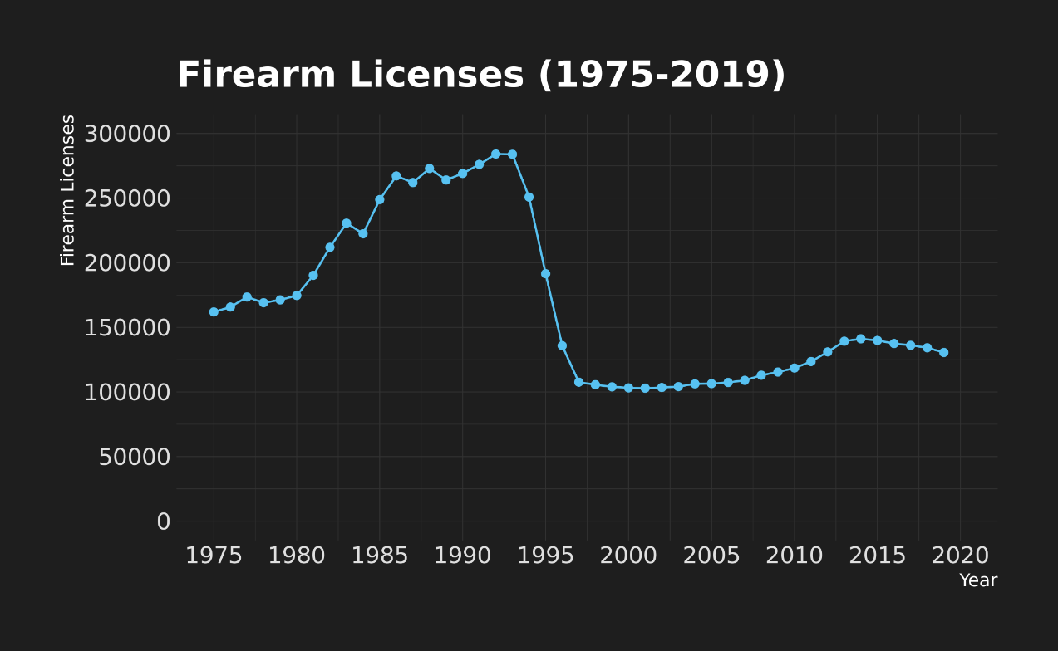

The next bit of data that I wanted to investegate was background checks. Background checks are a big part of the screening process for federally awared federal firearm licenses. From the following stacked bar chart, one will be able to see that Kentucky is the leader in background checks flowing through the NICS system for federal firearm licenses year after year. The next 3 highest states have almost 10 million less firearm related background checks in only a 5 year timespan. Since background checks are a large part of the data that I have to analyze, it is important to be able to vlearly view them. Remember that Kentucky has the most background checks for firearms when comparing the homicide data later on. The next few highest states includes Illinois, California, Texas, Flordia, and Pennsylvania. In this specific set of data, I was able to include the District of Columbia, Guam, Mariana Islands, Puerto Rico, and the Virgin Islands. Considering the fact that the firearm related homicides data only includes the District of Columbia though, I ommited the other territories of the United States to stay on target and be accurate.

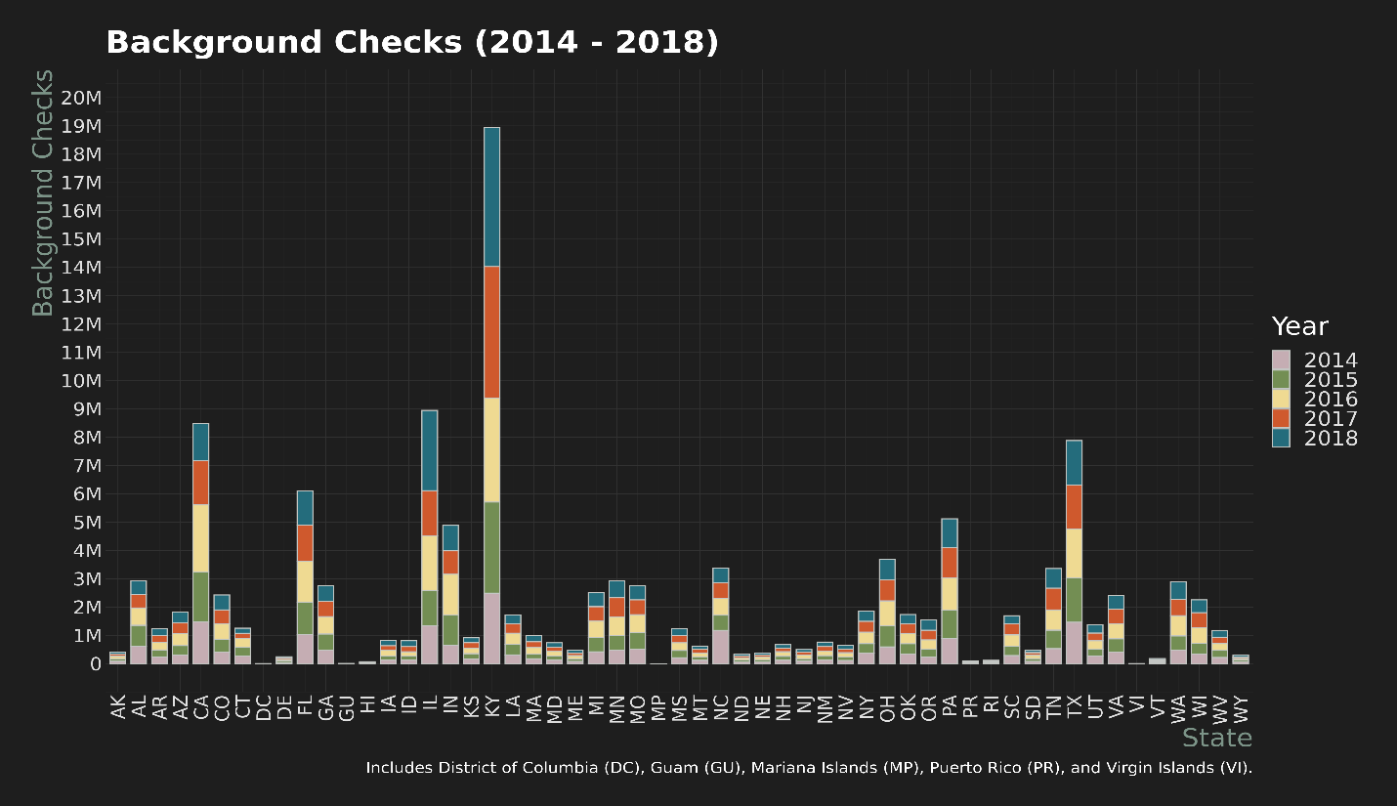

Firearm homicides account for almost fifty thousand murders out of a total of almost seventy thousand murders recorded in these UCR datasets for the years between 2014 and 2018. This is an average of 71.68% of murders according to the UCR data. To get a little more granular, in 2014 the percentage of firearm murders that made up all murders in that year was about 6%, 2015 was about 71%, 2016 was about 73%, 2017 was about 73%, and 2018 was about 73%. This shows that there is a clear slight upward trend in firearms being the choice of weapon used for murder. The UCR datasets included many different firearms including handguns, rifles, shotguns, other firearms, knives, or other cutting instruments, other, and hands, fists, etc. In the figure below, one will see not only where most homicides occur but also the span of the data over these five years. This visualization gives a great overview of the states who are having issues with firearm homicides, including those who are getting worse or are getting better. The box plot shows not only that California is the leader in firearm related murders, but also that it is consistently the leader. It is also apparent that Iowa is having an increasing issue with firearm related homicides. It is important to note that firearm homicide data for Florida, Guam, the Mariana Islands, Puerto Rico, and the Virgin Islands was not available from the FBI datasets.

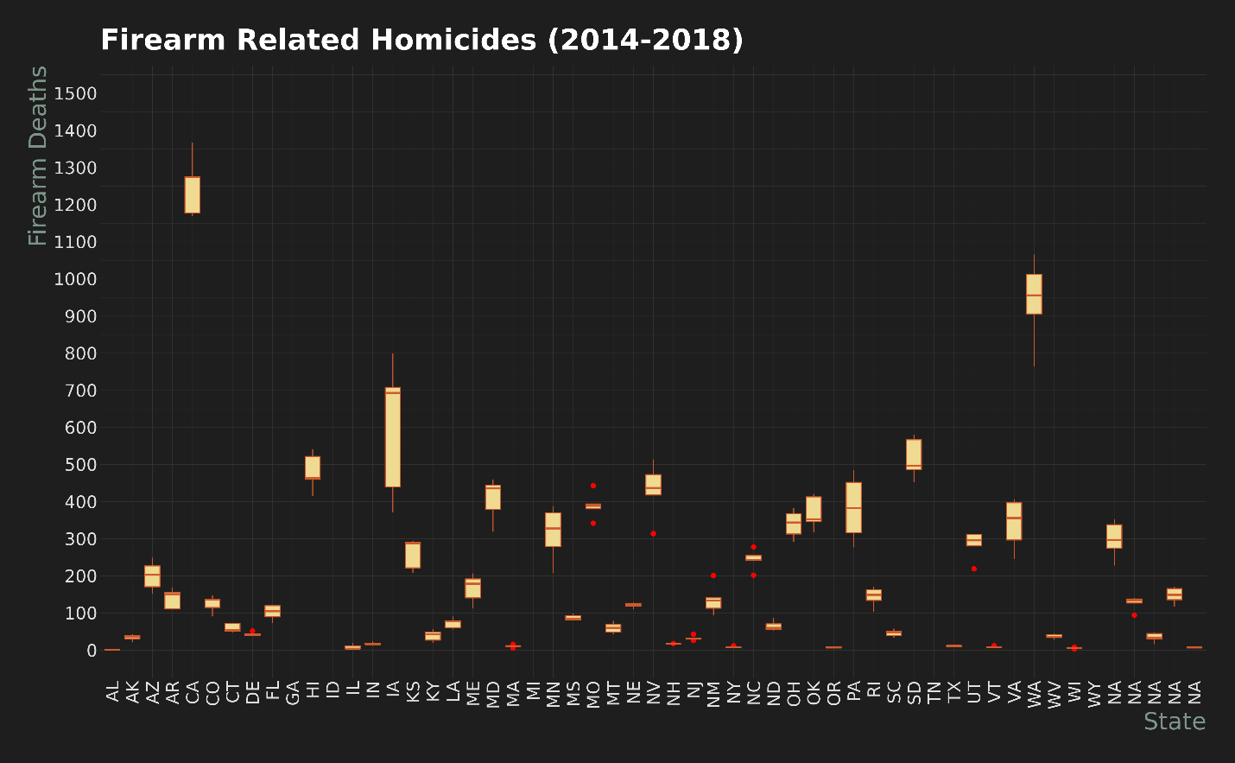

I think it is also important to view the data for each year as it shows a telling picture. The two constant leaders in firearm related homicides are always California and Texas. These graphs are a good way to see that.

**2014**

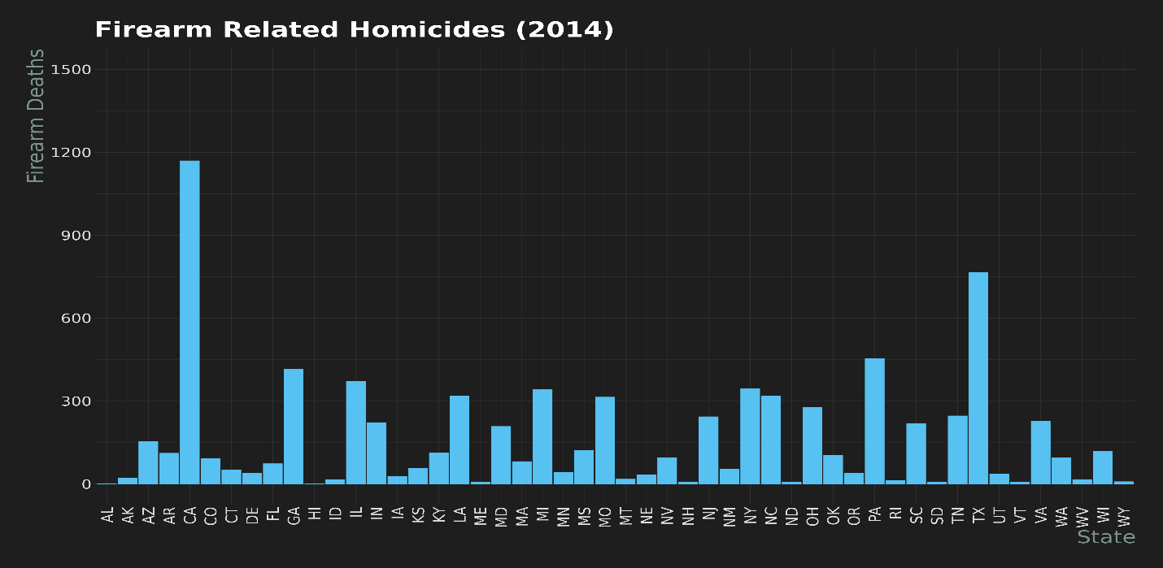

**2015**

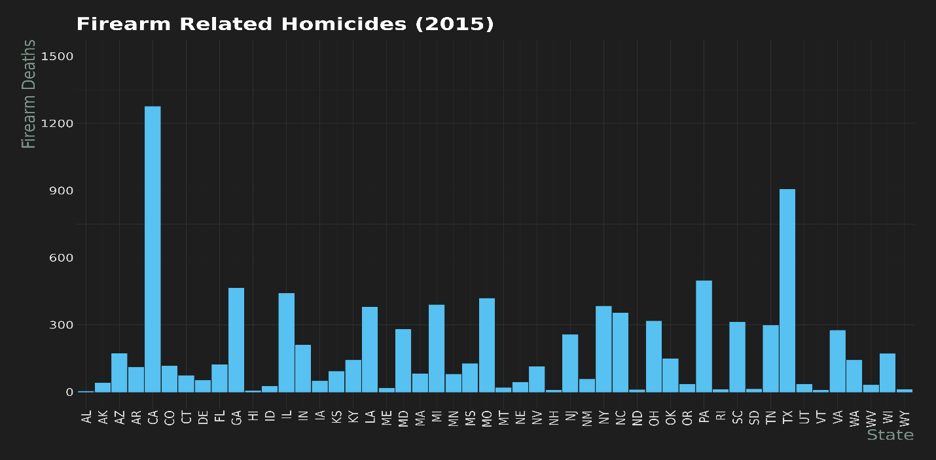

**2016**

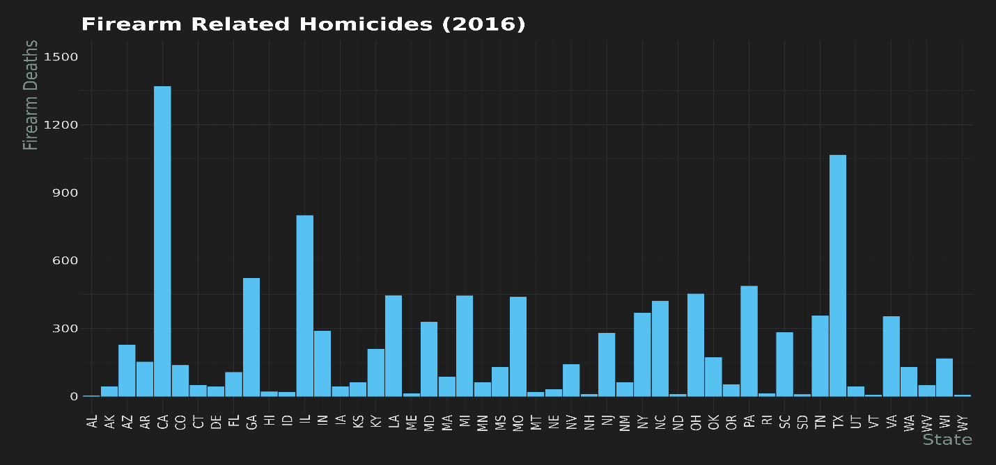

**2017**

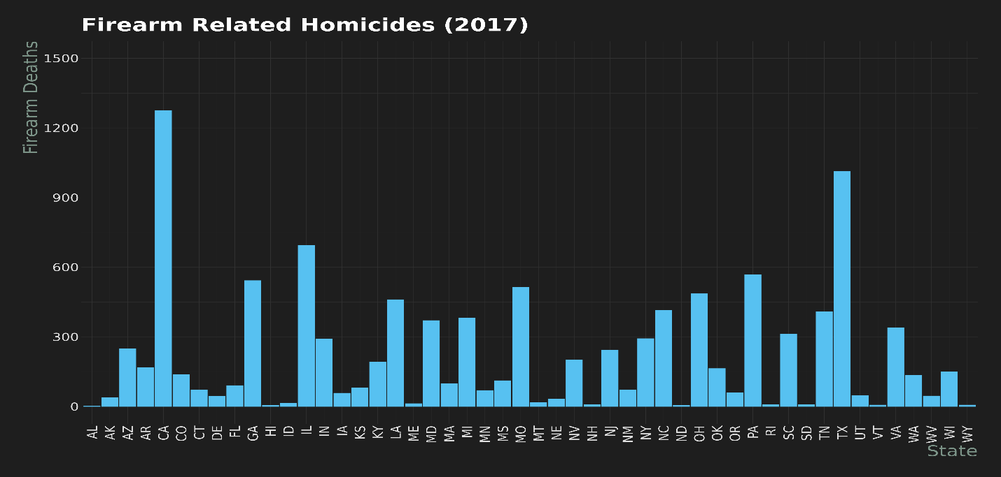

**2018**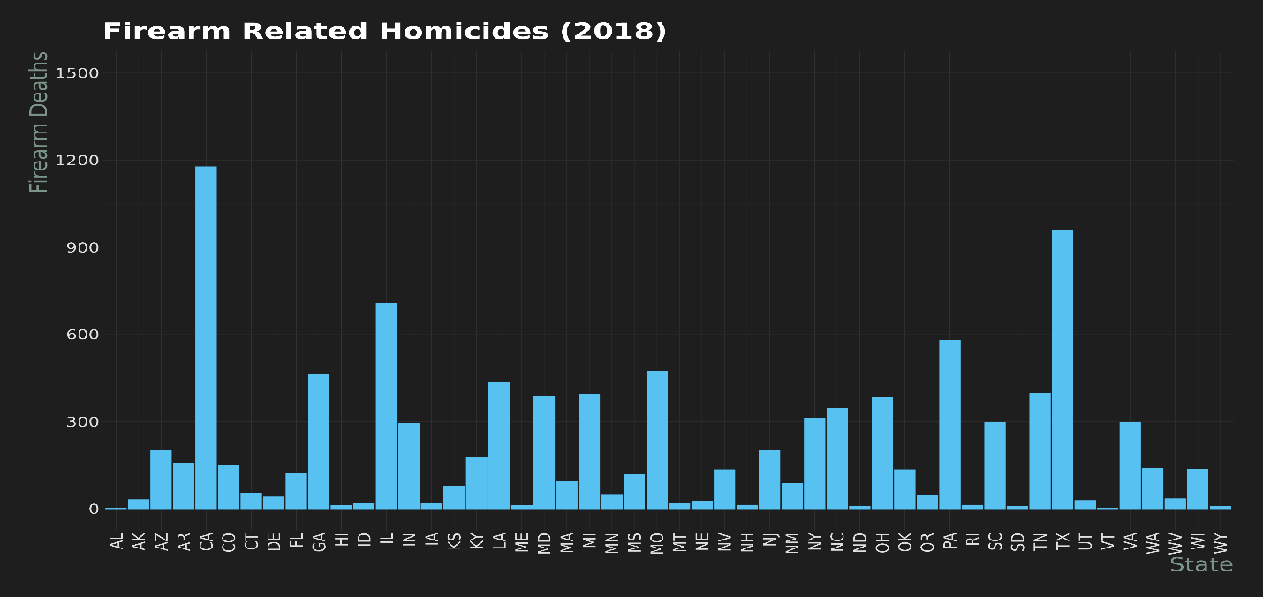

One of my favorite charts to display this data is a stacked bar chart like I used for the background check data. Below this paragraph I will include the stacked chart for firearm related homicides between the years of 2014 to 2018. It provides a large amount of data and details in a relatively small image. This should not be a surprise considering the other data I have analyzed so far that California is the leader, followed by Texas, Iowa, Pennsylvania, and Georgia. The most interesting part of this is that over the course of 5 years, California has had slightly more than a thousand more homicides than Texas, and if you ignore Texas, the next highest state is almost three thousand firearm homicides lower. It is important to know that homicide data for Florida, Guam, the Mariana Islands, Puerto Rico, and the Virgin Islands was not available from the FBI databases, so they are marked 0, or NA.

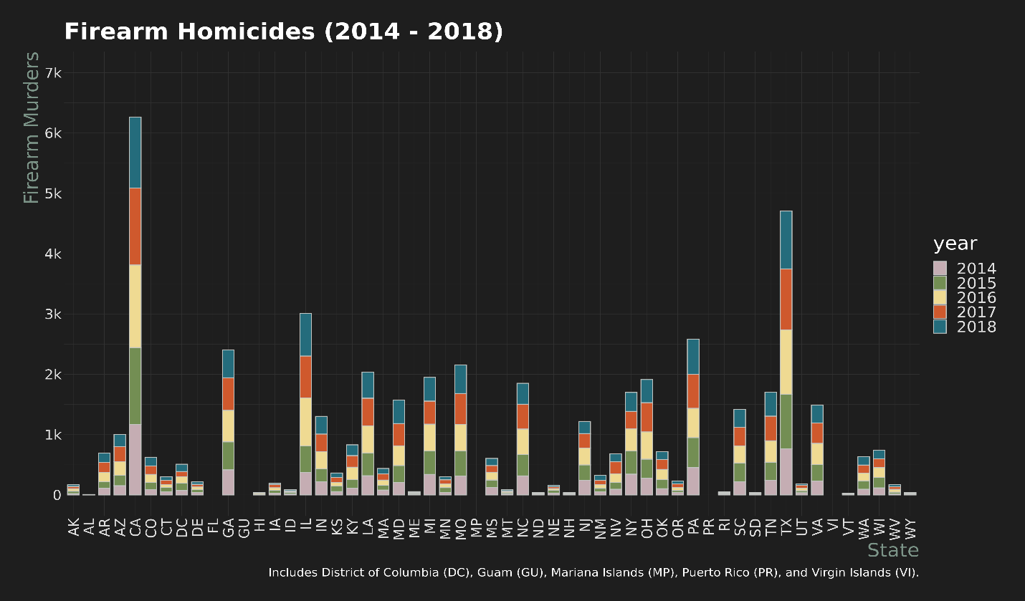

One of the points of this research assignment was to deduct if there was a correlation between federal firearm licenses and firearm related homicides. When I used R to run a Pearson’s Product-Moment correlation test, our findings include some interesting results. The returned P-value is about 5.0894 e-19 or 0.00000000000000000050894 with a correlation coefficient of about 0.524. This means that there is a very slight positive correlation, and the coefficient tells us that it is somewhat significant, but ultimately this means there is no correlation since the P-value is so close to 0. When trying to learn more, I found that a good way to confirm this hypothesis is to generate a side-by-side Q-Q plot for these two datasets. Below is that chart for one to analyze as well. Ultimately, this does not provide an answer to my initial question and the best way to go about analyzing that question is to make a request to the FBI for the data needed. Despite the waiting time for the data request process to be completed and the data to be transferred, the data exploration on this topic would be very telling and important.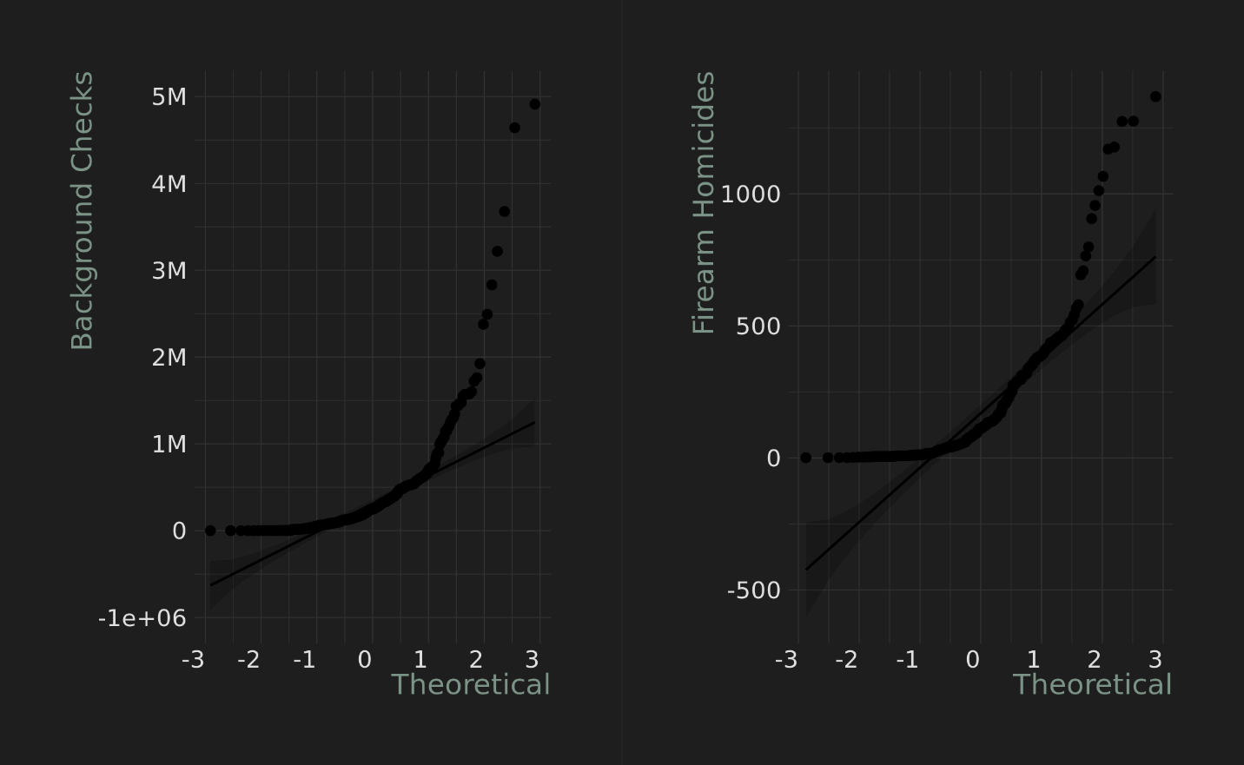

*Note: All images are available in my GitHub, at <https://github.com/danner26/Stockton-DSSA/tree/main/R/Data%20Exploration%20Project/png>

**Note: All the cleaned data I used is available in my GitHub, at <https://github.com/danner26/Stockton-DSSA/tree/main/R/Data%20Exploration%20Project/data>

**References**

Cohn, D’Vera, et al. “Gun Homicide Rate Down 49% Since 1993 Peak; Public Unaware.” *Pew Research Center’s Social & Demographic Trends Project*, 30 May 2020, www.pewsocialtrends.org/2013/05/07/gun-homicide-rate-down-49-since-1993-peak-public-unaware. Accessed 3 Dec. 2020.

“NICS Firearm Checks: Month/Year by State.” *Federal Bureau of Investigation*, Federal Bureau of Investigation, www.fbi.gov/file-repository/nics_firearm_checks_-_month_year_by_state.pdf/view. Accessed 2 Dec. 2020.

“NICS Firearm Checks: Year by State/Type.” *Federal Bureau of Investigation*, Federal Bureau of Investigation, www.fbi.gov/file-repository/nics_firearm_checks_-_year_by_state_type.pdf/view. Accessed 2 Dec. 2020.

“Table 12.” *FBI*, Federal Bureau of Investigation, ucr.fbi.gov/crime-in-the-u.s/2016/crime-in-the-u.s.-2016/topic-pages/tables/table-12. Accessed 1 Dec. 2020.

“Table 20.” *FBI*, Federal Bureau of Investigation, ucr.fbi.gov/crime-in-the-u.s/2014/crime-in-the-u.s.-2014/tables/table-20. Accessed 1 Dec. 2020.

“Table 20.” *FBI*, Federal Bureau of Investigation, ucr.fbi.gov/crime-in-the-u.s/2015/crime-in-the-u.s.-2015/tables/table-20. Accessed 1 Dec. 2020.

“Table 20.” *FBI*, Federal Bureau of Investigation, ucr.fbi.gov/crime-in-the-u.s/2017/crime-in-the-u.s.-2017/topic-pages/tables/table-20. Accessed 1 Dec. 2020.

“Table 20.” *FBI*, Federal Bureau of Investigation, ucr.fbi.gov/crime-in-the-u.s/2018/crime-in-the-u.s.-2018/topic-pages/tables/table-20. Accessed 1 Dec. 2020.

**Appendix (R Code)**

This data, images and code base is available on my GitHub, at <https://github.com/danner26/Stockton-DSSA/tree/main/R/Data%20Exploration%20Project>

Also this notebook can be viewed at <https://htmlpreview.github.io/?https://github.com/danner26/Stockton-DSSA/blob/main/R/Data%20Exploration%20Project/DataAnalysis.nb.html>

# **Firearms Data**

Hide

#install.packages(c("devtools", "tidyverse", "readr", "dplyr", "fiftystatr", "viridis", "mapproj", "ggpubr", "ggmap", "chron", "lubridate", "list", "ggthemes"))

library(devtools)

install_github("wmurphyrd/fiftystater")

library(tidyverse)

library(readr)

library(dplyr)

library(fiftystater)

library(viridis)

library(mapproj)

library(ggmap)

library(ggpubr)

library(chron)

library(lubridate)

library(list)

library(hrbrthemes)

setwd('/home/rstudio/dssa_workspace/R/Data Exploration Project/')

# **Read in the data**

Hide

FirearmLicenses <- read_csv("data/federal_firearms_licenses_1975-2019.csv")

BackgroundChecks_2014 <- read_csv("data/firearm_background_checks_bystate_2014.csv")

BackgroundChecks_2015 <- read_csv("data/firearm_background_checks_bystate_2015.csv")

BackgroundChecks_2016 <- read_csv("data/firearm_background_checks_bystate_2016.csv")

BackgroundChecks_2017 <- read_csv("data/firearm_background_checks_bystate_2017.csv")

BackgroundChecks_2018 <- read_csv("data/firearm_background_checks_bystate_2018.csv")

HomicideData_2014 <- read_csv("data/MurderVictims-2014.csv")

HomicideData_2015 <- read_csv("data/MurderVictims-2015.csv")

HomicideData_2016 <- read_csv("data/MurderVictims-2016.csv")

HomicideData_2017 <- read_csv("data/MurderVictims-2017.csv")

HomicideData_2018 <- read_csv("data/MurderVictims-2018.csv")

#Helper function

Hide

# Ref: https://5harad.com/mse125/r/visualization_code.html

addUnits <- function(n) {

labels <- ifelse(n < 1000, n, # less than thousands

ifelse(n < 1e6, paste0(round(n/1e3), 'k'), # in thousands

ifelse(n < 1e9, paste0(round(n/1e6), 'M'), # in millions

ifelse(n < 1e12, paste0(round(n/1e9), 'B'), # in billions

ifelse(n < 1e15, paste0(round(n/1e12), 'T'), # in trillions

'too big!'

)))))

return(labels)

}

#Total firearms plot

Hide

ggplot(FirearmLicenses, aes(x=year, y=total)) +

theme_modern_rc() +

geom_line() +

geom_point() +

scale_y_continuous(limits = c(0, 300000), breaks=seq(0, 300000, by = 50000)) +

scale_x_continuous(limits = c(1975, 2020), breaks=seq(1975, 2020, by = 5)) +

labs(x = "Year", y = "Firearm Licenses", title = "Firearm Licenses (1975-2019)")

ggsave("png/firearmlicenses_1975-2020.png")

#Summation Data

Hide

paste(sum(FirearmLicenses$total), "in 1975 - 2019")

FirearmLicenses_1418 <- FirearmLicenses %>% filter(between(year, 2014, 2018))

paste(sum(FirearmLicenses_1418$total), "in 2014 - 2018")

#2014 Homicide Data by State

Hide

ggplot(HomicideData_2014, aes(x=state, y=total_firearms)) +

theme_modern_rc() +

geom_bar(stat="identity") +

scale_y_continuous(limits = c(0, 1500), breaks=seq(0, 1500, by = 300)) +

scale_x_discrete(label=state.abb) +

labs(x = "State", y = "Firearm Deaths", title = "Firearm Related Homicides (2014)") +

theme(plot.title = element_text(size = 30), text = element_text(size=25), axis.text.x = element_text(angle=90, vjust=0.5, hjust=1, size = 18), axis.text.y = element_text(hjust=1, size = 18), axis.title.x = element_text(hjust = 1, size = 25, color = "#7C9488"), axis.title.y = element_text(hjust = 1, size = 25, color = "#7C9488"), plot.caption = element_text(size = 15))

ggsave("png/firearmhomicides-2014.png")

#2015 Homicide Data by State

Hide

ggplot(HomicideData_2015, aes(x=state, y=total_firearms)) +

theme_modern_rc() +

geom_bar(stat="identity") +

scale_y_continuous(limits = c(0, 1500), breaks=seq(0, 1500, by = 300)) +

scale_x_discrete(label=state.abb) +

labs(x = "State", y = "Firearm Deaths", title = "Firearm Related Homicides (2015)") +

theme(plot.title = element_text(size = 30), text = element_text(size=25), axis.text.x = element_text(angle=90, vjust=0.5, hjust=1, size = 18), axis.text.y = element_text(hjust=1, size = 18), axis.title.x = element_text(hjust = 1, size = 25, color = "#7C9488"), axis.title.y = element_text(hjust = 1, size = 25, color = "#7C9488"), plot.caption = element_text(size = 15))

ggsave("png/firearmhomicides-2015.png")

#2016 Homicide Data by State

Hide

ggplot(HomicideData_2016, aes(x=state, y=total_firearms)) +

theme_modern_rc() +

geom_bar(stat="identity") +

scale_y_continuous(limits = c(0, 1500), breaks=seq(0, 1500, by = 300)) +

scale_x_discrete(label=state.abb) +

labs(x = "State", y = "Firearm Deaths", title = "Firearm Related Homicides (2016)") +

theme(plot.title = element_text(size = 30), text = element_text(size=25), axis.text.x = element_text(angle=90, vjust=0.5, hjust=1, size = 18), axis.text.y = element_text(hjust=1, size = 18), axis.title.x = element_text(hjust = 1, size = 25, color = "#7C9488"), axis.title.y = element_text(hjust = 1, size = 25, color = "#7C9488"), plot.caption = element_text(size = 15))

ggsave("png/firearmhomicides-2016.png")

#2017 Homicide Data by State

Hide

ggplot(HomicideData_2017, aes(x=state, y=total_firearms)) +

theme_modern_rc() +

geom_bar(stat="identity") +

scale_y_continuous(limits = c(0, 1500), breaks=seq(0, 1500, by = 300)) +

scale_x_discrete(label=state.abb) +

labs(x = "State", y = "Firearm Deaths", title = "Firearm Related Homicides (2017)") +

theme(plot.title = element_text(size = 30), text = element_text(size=25), axis.text.x = element_text(angle=90, vjust=0.5, hjust=1, size = 18), axis.text.y = element_text(hjust=1, size = 18), axis.title.x = element_text(hjust = 1, size = 25, color = "#7C9488"), axis.title.y = element_text(hjust = 1, size = 25, color = "#7C9488"), plot.caption = element_text(size = 15))

ggsave("png/firearmhomicides-2017.png")

#2018 Homicide Data by State

Hide

ggplot(HomicideData_2018, aes(x=state, y=total_firearms)) +

theme_modern_rc() +

geom_bar(stat="identity") +

scale_y_continuous(limits = c(0, 1500), breaks=seq(0, 1500, by = 300)) +

scale_x_discrete(label=state.abb) +

labs(x = "State", y = "Firearm Deaths", title = "Firearm Related Homicides (2018)") +

theme(plot.title = element_text(size = 30), text = element_text(size=25), axis.text.x = element_text(angle=90, vjust=0.5, hjust=1, size = 18), axis.text.y = element_text(hjust=1, size = 18), axis.title.x = element_text(hjust = 1, size = 25, color = "#7C9488"), axis.title.y = element_text(hjust = 1, size = 25, color = "#7C9488"), plot.caption = element_text(size = 15))

ggsave("png/firearmhomicides-2018.png")

Hide

SelectHomicideData_2014 <- HomicideData_2014 %>% select(state, total_murders, total_firearms) %>% mutate(year = 2014)

SelectHomicideData_2015 <- HomicideData_2015 %>% select(state, total_murders, total_firearms) %>% mutate(year = 2015)

SelectHomicideData_2016 <- HomicideData_2016 %>% select(state, total_murders, total_firearms) %>% mutate(year = 2016)

SelectHomicideData_2017 <- HomicideData_2017 %>% select(state, total_murders, total_firearms) %>% mutate(year = 2017)

SelectHomicideData_2018 <- HomicideData_2018 %>% select(state, total_murders, total_firearms) %>% mutate(year = 2018)

state <- c('Guam', 'Guam', 'Guam', 'Guam', 'Guam', 'Mariana Islands', 'Mariana Islands', 'Mariana Islands', 'Mariana Islands', 'Mariana Islands', 'Puerto Rico', 'Puerto Rico', 'Puerto Rico', 'Puerto Rico', 'Puerto Rico', 'Virgin Islands', 'Virgin Islands', 'Virgin Islands', 'Virgin Islands', 'Virgin Islands', 'Florida', 'Florida', 'Florida', 'Florida', 'Florida')

total_murders <- c(NA, NA, NA, NA, NA, NA, NA, NA, NA, NA, NA, NA, NA, NA, NA, NA, NA, NA, NA, NA, NA, NA, NA, NA, NA)

total_firearms <- c(NA, NA, NA, NA, NA, NA, NA, NA, NA, NA, NA, NA, NA, NA, NA, NA, NA, NA, NA, NA, NA, NA, NA, NA, NA)

year <- c(2014, 2015, 2016, 2017, 2018, 2014, 2015, 2016, 2017, 2018, 2014, 2015, 2016, 2017, 2018, 2014, 2015, 2016, 2017, 2018, 2014, 2015, 2016, 2017, 2018)

SelectExtraHomicideData <- data.frame(state, total_murders, total_firearms, year)

HomicideData <- bind_rows(list(SelectHomicideData_2014, SelectHomicideData_2015, SelectHomicideData_2016, SelectHomicideData_2017, SelectHomicideData_2018, SelectExtraHomicideData)) %>% arrange(state)

st_crosswalk <- tibble(state = state.name) %>%

bind_cols(tibble(abb = state.abb)) %>%

bind_rows(tibble(state = "District of Columbia", abb = "DC")) %>%

bind_rows(tibble(state = "Guam", abb = "GU")) %>%

bind_rows(tibble(state = "Mariana Islands", abb = "MP")) %>%

bind_rows(tibble(state = "Puerto Rico", abb = "PR")) %>%

bind_rows(tibble(state = "Virgin Islands", abb = "VI"))

HomicideData <- left_join(HomicideData, st_crosswalk, by = "state")

HomicideData

#2014 Homicide Data by State

Hide

ggplot(HomicideData, aes(x=state, y=total_firearms, fill=year)) +

theme_modern_rc() +

geom_boxplot(outlier.colour="red", outlier.size = 2, color="#CF592D", fill="#EFDA92") +

scale_y_continuous(limits = c(0, 1500), breaks=seq(0, 1500, by = 100)) +

scale_x_discrete(label=state.abb) +

labs(x = "State", y = "Firearm Deaths", title = "Firearm Related Homicides (2014-2018)") +

theme(plot.title = element_text(size = 30), text = element_text(size=25), axis.text.x = element_text(angle=90, vjust=0.5, hjust=1, size = 18), axis.text.y = element_text(hjust=1, size = 18), axis.title.x = element_text(hjust = 1, size = 25, color = "#7C9488"), axis.title.y = element_text(hjust = 1, size = 25, color = "#7C9488"), plot.caption = element_text(size = 15))

ggsave("png/firearmhomicides_boxppplot.png")

Hide

percent <- function(x, digits = 2, format = "f", ...) {

paste0(formatC(100 * x, format = format, digits = digits, ...), "%")

}

paste("2014 Firearm Murder Percent: ", percent(sum(HomicideData_2014$total_firearms) / sum(HomicideData_2014$total_murders)))

paste("2015 Firearm Murder Percent: ", percent(sum(HomicideData_2015$total_firearms) / sum(HomicideData_2015$total_murders)))

paste("2016 Firearm Murder Percent: ", percent(sum(HomicideData_2016$total_firearms) / sum(HomicideData_2016$total_murders)))

paste("2017 Firearm Murder Percent: ", percent(sum(HomicideData_2017$total_firearms) / sum(HomicideData_2017$total_murders)))

paste("2018 Firearm Murder Percent: ", percent(sum(HomicideData_2018$total_firearms) / sum(HomicideData_2018$total_murders)))

total_murders <- sum(sum(HomicideData_2014$total_murders) + sum(HomicideData_2015$total_murders) + sum(HomicideData_2016$total_murders) + sum(HomicideData_2017$total_murders) + sum(HomicideData_2018$total_murders))

total_firearms <- sum(sum(HomicideData_2014$total_firearms) + sum(HomicideData_2015$total_firearms) + sum(HomicideData_2016$total_firearms) + sum(HomicideData_2017$total_firearms) + sum(HomicideData_2018$total_firearms))

paste("2014-2018 Firearm Murder Percent Average: ", percent(total_firearms / total_murders))

#Firearm murders stacked bar chart

Hide

color_table <- tibble(

Year = c("2014", "2015", "2016", "2017", "2018"),

Color = c("#C5ADB3", "#738E53", "#EFDA92", "#CF592D", "#246C7C")

)

HomicideData$year <- factor(HomicideData$year, levels = color_table$Year)

ggplot(HomicideData, aes(fill=year, x=abb, y=total_firearms)) +

theme_modern_rc() +

geom_bar(position=position_stack(reverse = TRUE), stat="identity", width=0.75, color="#C3C6C3") +

scale_y_continuous(label=addUnits, limits = c(0, 7000), breaks=seq(0, 7000, by = 1000)) +

labs(x = "State", y = "Firearm Murders", title = "Firearm Homicides (2014 - 2018)", caption = "Includes District of Columbia (DC), Guam (GU), Mariana Islands (MP), Puerto Rico (PR), and Virgin Islands (VI).") +

scale_fill_manual(values=color_table$Color) +

theme(plot.title = element_text(size = 30), text = element_text(size=25), axis.text.x = element_text(angle=90, vjust=0.5, hjust=1, size = 18), axis.text.y = element_text(hjust=1, size = 18), axis.title.x = element_text(hjust = 1, size = 25, color = "#7C9488"), axis.title.y = element_text(hjust = 1, size = 25, color = "#7C9488"), plot.caption = element_text(size = 15))

ggsave("png/firearmhomicides_stacked_2014-2018.png")

#2014 Background Check Data by State

Hide

ggplot(BackgroundChecks_2014, aes(x=State, y=Totals)) +

theme_modern_rc() +

geom_bar(stat="identity") +

scale_x_discrete(label=state.abb) +

scale_y_continuous(label=addUnits) +

labs(x = "State", y = "Firearm Deaths", title = "Background Checks (2014)") +

theme(plot.title = element_text(size = 30), text = element_text(size=25), axis.text.x = element_text(angle=90, vjust=0.5, hjust=1, size = 18), axis.text.y = element_text(hjust=1, size = 18), axis.title.x = element_text(hjust = 1, size = 25, color = "#7C9488"), axis.title.y = element_text(hjust = 1, size = 25, color = "#7C9488"), plot.caption = element_text(size = 15))

#Merge background checks

Hide

BackgroundChecks_2014 <- BackgroundChecks_2014 %>% select(State, Totals) %>% mutate(Year = 2014)

BackgroundChecks_2015 <- BackgroundChecks_2015 %>% select(State, Totals) %>% mutate(Year = 2015)

BackgroundChecks_2016 <- BackgroundChecks_2016 %>% select(State, Totals) %>% mutate(Year = 2016)

BackgroundChecks_2017 <- BackgroundChecks_2017 %>% select(State, Totals) %>% mutate(Year = 2017)

BackgroundChecks_2018 <- BackgroundChecks_2018 %>% select(State, Totals) %>% mutate(Year = 2018)

Background_Checks <- bind_rows(list(BackgroundChecks_2014, BackgroundChecks_2015, BackgroundChecks_2016, BackgroundChecks_2017, BackgroundChecks_2018)) %>% arrange(State)

st_crosswalk <- tibble(State = state.name) %>%

bind_cols(tibble(abb = state.abb)) %>%

bind_rows(tibble(State = "District of Columbia", abb = "DC")) %>%

bind_rows(tibble(State = "Guam", abb = "GU")) %>%

bind_rows(tibble(State = "Mariana Islands", abb = "MP")) %>%

bind_rows(tibble(State = "Puerto Rico", abb = "PR")) %>%

bind_rows(tibble(State = "Virgin Islands", abb = "VI"))

Background_Checks <- left_join(Background_Checks, st_crosswalk, by = "State")

Background_Checks

Hide

stateAbb <- function(n) {

labels <- ifelse(n == "Distric of Columbia", "DC",

state.abb)

return(labels)

}

#Background check stacked bar chart

Hide

color_table <- tibble(

Year = c("2014", "2015", "2016", "2017", "2018"),

Color = c("#C5ADB3", "#738E53", "#EFDA92", "#CF592D", "#246C7C")

)

Background_Checks$Year <- factor(Background_Checks$Year, levels = color_table$Year)

ggplot(Background_Checks, aes(fill=Year, x=abb, y=Totals)) +

theme_modern_rc() +

geom_bar(position=position_stack(reverse = TRUE), stat="identity", width=0.75, color="#C3C6C3") +

scale_y_continuous(label=addUnits, limits = c(0, 20000000), breaks=seq(0, 20000000, by = 1000000)) +

labs(x = "State", y = "Background Checks", title = "Background Checks (2014 - 2018)", caption = "Includes District of Columbia (DC), Guam (GU), Mariana Islands (MP), Puerto Rico (PR), and Virgin Islands (VI).") +

scale_fill_manual(values=color_table$Color) +

theme(plot.title = element_text(size = 30), text = element_text(size=25), axis.text.x = element_text(angle=90, vjust=0.5, hjust=1, size = 18), axis.text.y = element_text(hjust=1, size = 18), axis.title.x = element_text(hjust = 1, size = 25, color = "#7C9488"), axis.title.y = element_text(hjust = 1, size = 25, color = "#7C9488"), plot.caption = element_text(size = 15))

ggsave("png/backgroundchecks_stacked-2014-2018.png")

Hide

pearson_correlation <- cor.test(Background_Checks$Totals, HomicideData$total_firearms, method = "pearson")

pearson_correlation

paste("Pearson Correlation coefficient: ", pearson_correlation$estimate)

paste("Pearson P value: ", pearson_correlation$p.value)

kendall_correlation <- cor.test(Background_Checks$Totals, HomicideData$total_firearms, method = "kendall")

kendall_correlation

paste("Kendall Correlation coefficient: ", kendall_correlation$estimate)

paste("Kendall P value: ", kendall_correlation$p.value)

spearman_correlation <- cor.test(Background_Checks$Totals, HomicideData$total_firearms, method = "spearman")

spearman_correlation

paste("Spearman Correlation coefficient: ", spearman_correlation$estimate)

paste("Spearman P value: ", spearman_correlation$p.value)

Hide

bkchk_corr <- ggqqplot(Background_Checks$Totals, ylab = "Background Checks") + theme_modern_rc() + scale_y_continuous(label=addUnits, limits = c(-1000000, 5000000), breaks=seq(-1000000, 5000000, by = 1000000)) +

theme(axis.text.x = element_text(vjust=0.5, hjust=1, size = 10), axis.text.y = element_text(hjust=1, size = 10), axis.title.x = element_text(hjust = 1, size = 12, color = "#7C9488"), axis.title.y = element_text(hjust = 1, size = 12, color = "#7C9488"), plot.caption = element_text(size = 15))

homicide_corr <- ggqqplot(HomicideData$total_firearms, ylab = "Firearm Homicides") + theme_modern_rc() +

theme(axis.text.x = element_text(vjust=0.5, hjust=1, size = 10), axis.text.y = element_text(hjust=1, size = 10), axis.title.x = element_text(hjust = 1, size = 12, color = "#7C9488"), axis.title.y = element_text(hjust = 1, size = 12, color = "#7C9488"), plot.caption = element_text(size = 15))

cowplot::plot_grid(bkchk_corr, homicide_corr)

ggsave("png/correlation_qqplot.png")